Will Barlow

81776940

COSC 3

1. Yes, a collision will occur because collisions occur when two nodes transmit at the same time *and* when the propagation delay is less than L/R. Both of which are true in this circumstance.
2. It would be inefficient with a very large perimeter, especially if L/R is significantly less than the propagation delay, because a node would have to wait until after the frame has propagated the entire ring before it can release the token.
   1. D = 1010 1010 10
   2. G = 1011
   3. Temporary value = 1010 1010 1000
   4. D/G has an R = 0100
   5. R = 0100
3. Slotted: E(p) = N \* p (1 – p) ^ (N – 1)

Pure: E(p) = N \* p(1 – p) ^ (N – 1)

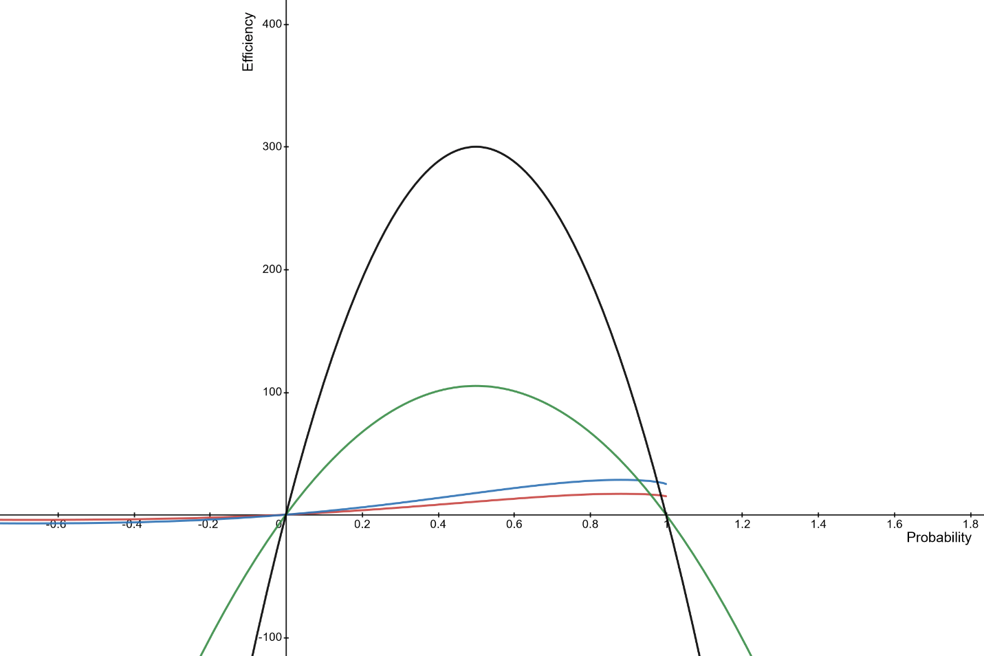

1. Assuming a jam signal of 48 bit times and given the propagation delay between node A and B = 245, the total jam signal = 245 + 48 = 293 bit times.

Node B employs kb. B = kb \* 512 = 512 bit times. So, B begins retransmitting when t = 512 + 293 + 96 = 901 bit times.

Node A employs ka. A = ka \* 512 = 0 bit times. A begins retransmission when t = 0 + 293+ 96 = 634 bit times.

A starts at time = 634. Start time + propagation delay between A and B = 634 + 245. So, node A’s signal reaches B at 879 bit times.

Thus, node B refrains from transmitting at its scheduled time to avoid the collision. s